Steller’s Jay aversiVE conditioning Treatment
In the Santa Cruz Mountains In 2015

Prepared and submitted by

Pia O. Gabriel^{1,2}, Portia Halbert³, and Richard T. Golightly^{1,2}

¹Humboldt State University
²H. T. Harvey & Associates
³California State Parks

February 2016

Report to COSCO BUSAN Trustee Council

Steller’s Jay Aversive Conditioning Treatment
In the Santa Cruz Mountains In 2015

Pia Gabriel^{1,2}, Portia Halbert³, and Richard Golightly^{1,2}
¹Humboldt State University, Wildlife Department, 1 Harpst Street, Arcata CA 95521
²H. T. Harvey & Associates, Ecological Consultants, 1125 16th Street, Arcata CA 95521
³California State Parks, 303 Big Trees Park Road, Felton CA 95018

Summary
Nest predation by corvids such as Steller’s jays has been identified as one of the main impediments to the recovery of marbled murrelet populations in California. Aversive conditioning techniques for Steller’s jays that exposed the jays to murrelet-colored and sized eggs treated with the emetic chemical carbachol has been effectively used to induce subsequent aversion to the murrelet-mimic eggs. Beginning in spring 2012, this conditioning technique has been implemented in State and County Parks in the Santa Cruz mountains with the goal of reducing egg predation by corvids on marbled murrelets nesting in the forests surrounding high-use visitor areas of these parks. In 2015, the fourth year of aversive conditioning treatment in Santa Cruz mountain parks, 1262 eggs colored to mimic murrelet eggs and laced with carbachol were deployed in two consecutive treatments at 631 locations across 4 different parks. Sixty-nine percent of the eggs were deployed in previously untreated areas, the largest of which was in Big Basin State Park. The initial predation rate on murrelet-mimic eggs throughout all treatment areas was well below initial predation rates in previous years, especially compared to the first treatment year of 2012. In addition, no Steller’s jays were detected on trail camera photos that documented a total of 45 wildlife interactions at mimic egg locations. These results suggested that conditioned aversion persisted across years, and the treatment effect on corvids in the area has now spread through the population. Conversely, in Big Basin State Park, the largest previously untreated area, the predation rate rose sharply from the first to the second treatment. This suggests a large population of mostly still untreated jays that travelled from the surrounding untreated forest to the extensive campgrounds at Big Basin State Park when the main camping season began. A third treatment may therefore be prudent in a park with such extensive visitor-use facilities to ensure treatment of the largest possible corvid population segment that can be reached with the available spatial treatment distribution. By contrast, the current spatial and temporal distribution of mimic egg treatments appears to work well for parks such as Memorial County Park, Butano State Park, and Portola Redwoods State Park, where medium to large sized campgrounds support a resident population of Steller’s jays and a modest population of visiting transients from surrounding forests. While deployments of murrelet mimic eggs should be continued annually at strategic, and, wherever possible, large and contiguous locations, evaluation of the treatment via interpretation of predation rate is likely to become more difficult as the variability of local treatment histories increases. Analysis of effectiveness may be more appropriate at a longer time interval, once an area is treated in multiple consecutive years.

Introduction
Predation on eggs of marbled murrelets (Brachyramphus marmoratus) has been linked to poor recruitment of young into the murrelet population, especially in the California, Oregon and Washington populations (McShane et al. 2004, Hébert and Golightly 2007, Golightly and Schneider 2009, Peery and Henry 2010). Corvids have been implicated as the most influential egg predators on murrelets. Fragmented forests provide the only remaining murrelet nesting habitat in California; unfortunately, these forests also support great densities of opportunistic corvids like Steller’s jays (Cyanocitta stelleri), increasing predation risk on murrelet eggs (Marzluff et al. 2004, Marzluff and Neatherlin 2006, Golightly and Gabriel 2009, Malt and Lank 2009). Effective reductions of egg predation require manipulation of the predator population density or predation behavior.
Aversive conditioning techniques for Steller’s jays that exposed the jays to murrelet-colored and sized eggs treated with carbachol (carbamylcholine chloride) effectively induced subsequent aversion to the murrelet-mimic eggs in laboratory and field tests (Gabriel and Golightly 2014). Peery and Henry (2010) calculated that reductions in corvid predation on murrelet nests between 40 and 70% (depending on a range of assumptions regarding nesting ratios and predation rates) would be necessary to stabilize the marbled murrelet population segment located in central California. In 2012, the aversive conditioning technique was introduced in the Santa Cruz mountains; carbachol-laced murrelet-mimic eggs were deployed at densities of 0.5 – 2 eggs / ha, and the technique reduced corvid predation on murrelet-mimic eggs by 44% to 80% (Gabriel et al. 2013). The treatment was successfully repeated in spring 2013, when aversive conditioning was again applied in Butano State Park and Portola Redwoods State Park, and for the first time in campgrounds at Memorial County Park (Gabriel et al. 2014). Consistently low predation rates on murrelet-mimic eggs deployed outside of campgrounds in 2013 suggested that jays that were treated in 2012 and were still resident in the treatment areas in 2013 continued to avoid mimic eggs in 2013. Gabriel et al. (2014) concluded that the length of retention of the aversive conditioning lasted at least one year. In 2014, murrelet-mimic eggs were deployed in some previously treated areas and also in some new areas in Butano State Park, Portola Redwoods State Park, Memorial County Park, Pescadero Creek County Park, and Sam McDonald County Park. The success of the 2014 treatment was difficult to assess due to the variable treatment histories of deployment areas, discontinuity of treatment areas, and likely also the effects of the severe drought conditions in 2014 (Gabriel et al. 2015).
To ensure the likelihood of improved reproductive success for murrelets in central California, aversive conditioning of Steller’s jays was again applied as a management technique in Memorial County Park, Pescadero Creek County Park, and Sam McDonald County Park in spring 2015, and is described here. In addition, the treatment area included additional trails at Pescadero Creek and Sam McDonald County Parks, and a new treatment area in Big Basin State Park in 2015.

Methods
Aversive conditioning treatment was focused on roads and trails in forested areas surrounding high-use visitor areas of Big Basin State Park, Memorial County Park, Pescadero Creek County Park, and Sam McDonald County Park in San Mateo County in spring 2015. These areas were identified as being among the habitat important to murrelet recovery and currently occupied by murrelets in central California by the U.S. Fish and Wildlife Service (USFWS 2008). Treatment consisted of deployment of carbachol-laced eggs that mimicked murrelet eggs in contiguous habitat used by jays in old growth or second growth forest stands around campgrounds. In Memorial, Pescadero Creek, and Sam McDonald County Parks, aversive conditioning treatment had previously been applied to several roads and trails in 2013 and/or 2014 (Gabriel et al. 2014, Gabriel et al. 2015). The treatment area in 2015 encompassed some portions of the 2013 and 2014 treatment areas, but 69% of the 2015 treatments were applied in previously untreated areas.
Treatment areas were chosen in areas with anthropogenic habitat alteration and where food supplementation had affected jay populations (within 1 to 2 km of high-use visitor attractions; Goldenberg 2013). Furthermore, the forests surrounding the parks and campgrounds that were the focus of treatment were very fragmented, and thus very attractive to Steller’s jays. We used the rationale that, instead of merely treating islands of murrelet breeding habitat, edges between murrelet breeding habitat and surrounding forest were particularly important for also treating jays that may be predating murrelet nests (Marzluff et al. 2004, Malt and Lank 2009).
Egg preparation
Laboratory preparation of treatment eggs began in February using raw, small-sized chicken eggs that weighed 42 to 45 g. A small hole of approximately 3 mm diameter was drilled in the narrowest end of the shell using a rotary tool. We extracted 0.5 to 1 ml of egg contents with a syringe to provide for the subsequent addition of aversive chemical solution and for expansion of egg contents with temperature. We then injected at least 0.24 ml of a sterile solution containing 100 mg/ml carbachol (carbamylcholine chloride, 99%, Acros Organics, Thermo Fisher Scientific, New Jersey, U.S.A; resulting in approximately 0.55 - 0.7 mg carbachol / g egg mass). A piece of wire approximately 2 mm in diameter, with the tip bent at an approximate angle of 10° and attached to a rotary tool was inserted into the drilled hole. The rotary tool was activated for 1 to 2 s, resulting in a short burst of whisking to thoroughly blend the contents of the egg with the carbachol solution. The egg surface was then wiped clean and the hole sealed with hot glue (Dualmelt G GS25DT, Stanley Tools, Connecticut, U.S.A.).
Eggs were colored with paint in a blue-green hue closely resembling murrelet eggs (Oceanfront 660, Benjamin Moore & Co., New Jersey, U.S.A.) using a spray can. Irregular black spotting as characteristic of murrelet eggs was applied with dilute acrylic paint. An approximately 1 cm² piece of double sided hook-and-loop fastener (Velcro brand) was then attached with hot glue to all eggs along 2 cm of their widest side. A matching piece of hook-and-loop fastener was glued to a 20 cm black zip tie (8” x 3/16” Black Nylon Cable Tie; Storehouse, Harbor Freight Tools, Camarillo, California, U.S.A.). This provided a flexible attachment that allowed us to fasten eggs to tree branches with the zip tie.
Field treatment
Each treatment consisted of placing treated eggs at intervals of 100 m along roads and trails throughout the parks in the areas surrounding high-use visitor attractions. Eggs were placed in trees that provided a branch suitable for placing an egg in the sub-canopy, between 3 and 5 m height above ground. Given the great density of trails surrounding high-use visitor areas in the central California parks, egg density approximated between 0.5 to 2 treated eggs / ha. The use of roads and trails for egg deployment resulted in the greatest egg densities in areas with greatest density of human development or use, and coincided with greatest expected jay densities (Bensen 2008, Suddjian 2009).
Jay territories largely overlap among mates and to varying degrees among neighbors (Brown 1963). Additionally, predation by rodents may have previously caused some loss of treated eggs before jays could find the treated eggs. Consequently, some jays may not have been exposed to eggs in the first treatment. Therefore, two temporally distinct treatments were implemented. The goal of a second treatment was to maximize the number of jays exposed to treated eggs. The first field treatment was conducted between 3 April and 23 April and the second treatment between 24 April and 18 May 2015. Removal of egg remains and egg-attachment materials occurred between 7 May and 5 June 2015. In the first treatment, 274 treated eggs were placed in Big Basin State Park, 120 in Memorial County Park, 147 in Pescadero Creek County Park, and 87 treated eggs were placed in Sam McDonald County Park (Fig. 1).
During the second treatment in 2015, the disposition of eggs placed during the first treatment was determined. This resulted in intervals of 20 to 25 days (21.8 ± 1.5, mean ± SD) between the first treatment and assessment of egg predation. During the removal of remains after the second treatment, the disposition of eggs placed during the second treatment was determined. This resulted in intervals of 13 to 24 days (21.0 ± 1.5) between the second treatment and assessment of egg predation. Disposition of eggs was scored into four categories based on visible signs of predation. Intact eggs were classified as ‘no predation’. Eggs that were missing, or found opened or destroyed but without conclusive sign of corvid predation were classified as ‘possible corvid predation’. This category included eggs that appeared to be predated by non-corvid predators (as indicated e.g. by tooth marks found on egg shell edges), because such eggs could have also been predated by corvids before or after the predation event by the non-corvid predator. In accordance with our observations of eggs predated by jays in preceding captive experiments (pecked holes, jagged edges on shells, Gabriel & Golightly 2014), we classified any egg remains that showed such conclusive signs as ‘corvid predation’. When eggs or egg remains were found, but not enough evidence collected to assign a predation category, we classified such cases as ‘unknown’ (Table 1). In 2015, all revisited eggs fulfilled the time interval criteria (re-visitation 14 to 35 days after treatment) for correct classification of predation that was established in earlier studies, specifically the field assessment of aversive conditioning effectiveness on jays in Redwood National Park (Gabriel and Golightly 2011). These criteria were also used for the same analyses of predation data obtained during the previous studies in central California parks.
The effectiveness of aversive conditioning in protecting murrelet-mimic eggs from predation in 2015 was determined by comparing the predation rate of murrelet-mimic eggs between the first and second treatments in the four parks. For these comparisons, eggs classified as unknown were excluded from analyses. First we compared the overall proportions of predated mimic eggs in the two treatments. Second we compared the proportions of predation on mimic eggs located in or close to campgrounds within the treatment area to the remainder of the treatment area. We used Chi-square tests to compare proportions of mimic eggs in each predation category (not predated, possibly corvid predated, and corvid predated). When significant differences in these proportions between the respective sets of eggs were found (first treatment compared to second treatment, or within campgrounds compared to outside campgrounds, or close to campgrounds compared to away from campgrounds), we then used two different groupings of predation categories for more detailed comparisons. First, for a maximally inclusive measure of corvid predation, eggs that were categorized as possibly corvid predated and as corvid predated were added together and compared to eggs that were not predated. Second, for a maximally stringent and conservative measure of corvid predation, only eggs that were categorized as corvid predated were used and contrasted to eggs that were not predated (which resulted in eggs categorized as possibly corvid predated being excluded from comparisons). Where contingency tables contained expected counts below 5 in any category, we used Fisher’s exact test (for 2x2 tables) or Monte Carlo simulations with 10,000 iterations to estimate Chi-Square and P-values (for larger tables).
We examined whether proportions of predation categories differed between the first and second treatment. Aversive conditioning treatment of a persisting jay population in the preceding year appeared to have had a significant effect on egg predation detected the following year (Gabriel et al. 2014, Gabriel et al. 2015). The treatment histories of different parks and areas within parks differed widely. We therefore examined whether proportions of predation categories differed between the two treatments in 2015 separately for eggs deployed in 1) the previously entirely untreated Big Basin State Park, 2) the previously untreated areas in Pescadero and Sam McDonald County Parks (two closely adjacent parks with similar treatment histories), 3) the previously entirely treated area of Memorial County Park, and 4) previously treated areas in Pescadero and Sam McDonald County Parks.
We assessed whether effectiveness of aversive conditioning treatment and adequacy of treatment density differed between campgrounds and areas outside of campgrounds. For this purpose we compared proportions of predation categories between egg locations in campgrounds to locations outside campgrounds (Fig. 1) in the first treatment, and in the second treatment. Using an estimated 1 km radius of anthropogenic effects of campgrounds on jay populations, we also compared proportions of predation categories between egg locations within 1 km of campgrounds to egg locations more than 1 km away from campgrounds (Fig. 1). Because of the different treatment histories, we again conducted separate analyses for Big Basin State Park and Memorial County Park. All treatment locations in Pescadero Creek and Sam McDonald County Parks were outside of, and further than 1km from campgrounds, and were therefore not included in these analyses.
We also monitored interactions of corvids and other species with treated eggs with infra-red motion sensor cameras (Trophy Cam Trail Camera, Bushnell Outdoor Products, Kansas, U.S.A.). Cameras were placed at egg locations distributed throughout the treatment area and visited approximately once a week. Five cameras were placed at 5 different egg locations in Memorial County Park. Five other cameras were placed at 6 different locations in Big Basin State Park. Once a camera-monitored egg was predated, the camera was moved to a new location. If predation by a non-corvid predator was suspected, the immediate surroundings of the tree were searched for any animals or sign of animals. Photos obtained from trail cameras allowed identification of predators and behavioral evaluation of animal interactions with treated eggs.

Results
Trail cameras acquired 153 pictures of four different wildlife species interacting with or moving in close vicinity of mimic eggs. Series of photographs that were acquired within 10 minutes of each other at the same location likely depicted the same individual animal and were interpreted cumulatively as single interactions. According to these criteria, we identified 45 unique wildlife interactions. Some interactions involved the same species at the same location or nearby locations that may have been in close enough proximity to be included in the same home range. No interactions included Steller’s jays. However, 4 interactions at 4 different locations (3 at Big Basin State Park, 1 at Memorial County Park) showed common ravens (Corvus corax). One of those interactions strongly suggested that the raven removed the mimic egg from the branch. The most frequently detected wildlife were unknown mouse species with 20 recorded interactions, with 14 of these interactions recorded at one location, and the remaining 6 interactions at one other location. We also recorded 15 interactions of raccoon (Procyon lotor) at a single location, and 6 interactions of gray squirrels (Sciurus griseus) at 4 different locations. Except for the single interaction by a raven, none directly documented egg predation.
Aversive conditioning effects in areas with no prior treatment history
Among all egg locations in Big Basin State Park, the distribution of predation categories differed significantly between the first and second treatments (Χ²₂ = 57.08, P < 0.001, Fig. 2). Using both eggs categorized as corvid predated and as possibly corvid predated (maximally inclusive measures), the proportion of murrelet-mimic eggs predated in the second treatment was 116% more than in the first treatment (Χ²₁ = 55.71, P < 0.001). Using only eggs categorized as corvid predated (maximally stringent measures), the proportion of predated murrelet-mimic eggs did not differ between the two treatments (Χ²₁ = 0.85, P = 0.358, Fig. 5).
Among those egg locations in Pescadero Creek and Sam McDonald County Parks where no prior treatment had been applied, the distribution of predation categories did not differ significantly between the first and second treatments (Χ²₂ = 2.68, P = 0.262, Fig. 3).
Aversive conditioning effects in areas with prior treatment
Among all egg locations in Memorial County Park, the distribution of predation categories differed significantly between the first and second treatments (Χ²₂ = 11.63, P = 0.003, Fig. 4). Using both eggs categorized as corvid predated and as possibly corvid predated, the proportion of murrelet-mimic eggs predated in the second treatment was 50% less than in the first treatment (Χ²₁ = 10.76, P = 0.001). Using only eggs categorized as corvid predated, the proportion of murrelet-mimic eggs predated in the second treatment was 69% less than in the first treatment (Χ²₁ = 6.85, P = 0.009, Fig. 4).
Among those egg locations in Pescadero Creek and Sam McDonald County Parks where prior treatment had been applied in 2013 or 2014, the distribution of predation categories differed between the two treatments (Χ²₁ = 11.82, P = 0.003). Using both eggs categorized as corvid predated and as possibly corvid predated, the proportion of predated murrelet-mimic eggs did not differ between the two treatments (Χ²₁ = 1.21, P = 0.272, Fig. 5). However, using only eggs categorized as corvid predated, the proportion of murrelet-mimic eggs predated in the second treatment was 86% less than in the first treatment (Χ²₁ = 3.80, P = 0.051).
Comparisons between egg locations relative to campgrounds
Among egg locations in Big Basin State Park, the distribution of predation categories did not differ between egg locations in campgrounds and locations outside of campgrounds in the first treatment (Χ²₂ = 3.00, P = 0.223, Fig. 6a), and in the second treatment (Χ²₂ = 1.13, P = 0.570, Fig. 6a).
Among egg locations in Memorial County Park, the distribution of predation scores differed between egg locations in campgrounds and locations outside of campgrounds in the first treatment (Χ²₂ = 24.73, P < 0.001, Fig. 6b). Using both eggs categorized as corvid predated and as possibly corvid predated, the proportion of murrelet-mimic eggs predated in campgrounds was 131% larger than outside of campgrounds (Χ²₂ = 12.88, P < 0.001). However, using only eggs categorized as corvid predated, the proportion of predated murrelet-mimic eggs did not differ between locations in and outside of campgrounds (Χ²₂ = 0.239, P = 0.625). In the second treatment, the distribution of predation scores did not differ significantly between egg locations in campgrounds and locations outside of campgrounds (Χ²₂ = 3.14, P = 0.208).
When assessing effects of campgrounds on jay populations surrounding these campgrounds, the distribution of predation categories in Big Basin State Park differed between egg locations within 1 km of campgrounds and locations more than 1 km away from campgrounds in the first treatment (Χ²₂ = 13.32, P = 0.001; Fig. 7). Using both eggs categorized as corvid predated and as possibly corvid predated, the proportion of murrelet-mimic eggs predated within 1 km of campgrounds was 46% smaller than more than 1 km away from campgrounds (Χ²₂ = 9.23, P = 0.002). However, using only eggs categorized as corvid predated, the proportion of predated murrelet-mimic eggs did not differ between locations within and outside of 1 km from campgrounds (Χ²₂ = 1.21, P = 0.271). In the second treatment in Big Basin State Park, the distribution of predation scores also differed between egg locations within 1 km of campgrounds and locations more than 1 km away from campgrounds (Χ²₂ = 8.29, P = 0.016; Fig. 7). Using both eggs categorized as corvid predated and as possibly corvid predated, the proportion of murrelet-mimic eggs predated within 1 km of campgrounds was 30% smaller than more than 1 km away from campgrounds (Χ²₂ = 7.36, P = 0.007). However, using only eggs categorized as corvid predated, the proportion of predated murrelet-mimic eggs did not differ between locations within and outside of 1 km from campgrounds (Χ²₂ = 2.35, P = 0.125).
In Memorial County Park, only 5 eggs were placed more than 1 km away from campgrounds, and thus could not be compared to eggs placed within 1 km of campgrounds.

Discussion
Murrelet-mimic eggs laced with carbachol have been used previously in the forests surrounding high-use visitor areas of central California parks with the goal of reducing predation by Steller’s jays on the eggs of murrelets nesting in these forests. In 2015, these treatments with murrelet-mimic eggs were again applied in areas of several parks that previously received treatment in 2013 or 2014, and included some previously untreated areas as well. New treatment areas included both additional trails and roads in parks where other areas had received previous treatment, and a large area in and surrounding the large and wide-spread campgrounds of big Basin State Park. Given the increasingly variable treatment histories and uneven, widely spread spatial distribution of treatment locations, interpretation of predation patterns on the deployed mimic eggs is less clear than previously.
In 2015, initial predation rates on mimic eggs (14-38%, depending on treatment area) were substantially less than initial predation rates of earlier treatment years in central California parks, especially compared to the first treatment year of 2012 (51% overall estimated initial predation rate). This observation may represent the continuation of a downward trend in initial predation over time that we also observed in previous treatment years (Gabriel et al. 2014; Gabriel et al. 2015). The reduced initial predation compared to earlier years, even in previously untreated areas, may indicate that the treatment effect on corvids in the area has now spread through the population, where juvenile Steller’s jays and other corvids that are dispersing from treated areas are settling in adjacent, previously untreated areas while retaining either their conditioned aversion for murrelet-mimic eggs or a reluctance to feed on eggs presumably learned from their conditioned parents.
Conversely, in Big Basin State Park, the largest previously untreated area, the predation rate rose sharply from the first to the second treatment, to levels similar to initial predation rates in previously untreated areas observed in 2014. This suggests a large population of mostly still untreated jays that travelled from the surrounding untreated forest to the extensive campgrounds at Big Basin State Park when the main camping season began (between the first and second treatment periods). Biologists working in the Santa Cruz mountains parks observed that the jay population using campgrounds increased many-fold with the start of the camping season and the accompanying availability of anthropogenic food (P. Halbert, E. West, pers. comm.). In Big Basin State Park, this effect seems magnified by the extremely large campground area and capacity for visitors, in comparison to all other parks in the area. This appears to result in an attraction of jays from areas even more than 2 km away into the extensive Big Basin State Park campgrounds (E. West, unpublished data). To ensure treatment of the largest possible corvid population segment that can be reached with the available spatial treatment distribution in a park with such extensive visitor-use facilities, a third treatment may therefore be prudent. A third treatment may be most effective during the peak of summer and visitor-use, or alternatively during late summer (September), when visitor-use is dropping off but jay pairs who have concluded breeding and their new offspring are still moving into and through campgrounds in large numbers (Brown 1963, P. Halbert, E. West, pers. comm.).
In Memorial County Park, most of the 2015 treatment area had been treated for the first time in 2014 (with very few locations treated for the first time in 2013). The initial overall predation rate in Memorial County Park (38%) was very similar to predation levels we detected in the first treatment of 2013 in Portola and Butano State Parks; these two parks had been treated for the first time in 2012. This parallel in relatively low initial predation rates in second-year treatments may be consistent with the retention of acquired aversions by resident corvid populations into subsequent years. It may also suggest that the current spatial and temporal distribution of mimic egg treatments works well for parks such as Memorial County Park, Butano State Park, and Portola Redwoods State Park, where medium to large sized campgrounds support a resident population of Steller’s jays and a modest population of visiting transients from surrounding forests.
The greatest egg predation rates in 2015 were associated with proximity to campgrounds (Memorial County Park: greatest predation rate during first treatment within campgrounds; Big Basin State Park: greatest predation rate during second treatment in areas within 1km of campgrounds), lending support to the interpretation that the food available in campgrounds attracts previously untreated corvids and other predators. However, almost all predation in general, and peaks in predation rates in particular were attributable to eggs classified as possibly corvid predated, not to eggs classified as corvid predated. In addition, no Steller’s jays were detected on trail camera photos in 2015, and the number and proportion of jay detections has been steadily decreasing over the years (2012: 88% of 51 wildlife interactions, 2013: 35% of 55 interactions, 2014: 9% of 11 interactions, 2015: 0% of 45 interactions). These findings may support the speculation that at least some, maybe much of the increase in egg predation during these incidents of maximum predation rates was attributable to predation by non-corvids that moved into treatment areas to take advantage of anthropogenic food. It may also support the idea that the conditioned aversion is indeed increasingly spreading through the jay population in the central California parks region.

Management Recommendations
The addition of new lands and repeat treatments, and a longer history of exposure of jay populations to previous treatments leads to difficulty for interpretation of monitoring results. Study complexity, however, should not be confused with management effectiveness. The overall results of very low initial predation rates, and the absence of any jay interactions recorded in trail camera photos may indicate that the overall goal of successful and sustainable aversive conditioning of the Steller’s jay populations in the Santa Cruz mountains has been achieved by the continuing treatments. While deployments of murrelet mimic eggs should be continued annually at strategic, and, wherever possible, large and contiguous locations, evaluation of the treatment via interpretation of predation rate is likely to become more difficult as the variability of local treatment histories increases. Analysis of effectiveness may be more appropriate at a longer time interval, once an area is treated in multiple consecutive years.

Acknowledgments
This research was funded by the Cosco Busan Oil Spill Restoration Fund and administered by California Department of Parks and Recreation. We are particularly indebted to the Office of Spill Prevention and Response, California Department of Fish and Wildlife for their consideration of testing novel approaches to improve Marbled Murrelet nesting habitat, especially Dr. S. Hampton. We also thank C. Marn, J. Whitlock and L. Roberts of U.S. Fish and Wildlife Service for facilitating the project. J. Torres, H. Ernst, S. Gordon, and M. Michelson carried out field efforts and provided valuable assistance with data evaluation.

References
Bensen, K.J. 2008. Forest and beach corvid monitoring and management, Redwood Creek corvid and backcountry campsite mapping, trail and backcountry management plan implementation – 2008 progress report. National Park Service, Redwood National and State Parks, Orick, CA.
Brown, J.L. 1963. Aggressiveness, dominance and social organization of the Steller’s jay. Condor 65: 460-484.
Gabriel, P.O., and R.T. Golightly. 2014. Aversive conditioning of Steller’s jays to improve marbled murrelet nest survival. Journal of Wildlife Management 78: 894-903.
Gabriel, P.O., and R.T. Golightly. 2011. Experimental assessment of taste aversion conditioning on Steller’s Jays to provide potential short-term improvement of nest survival of Marbled Murrelets in northern California. Report submitted to National Park Service, Orick, CA. 34 pp.
Gabriel, P.O., P. Halbert, and R.T. Golightly. 2013. Steller’s jay conditioned taste aversion treatment in the Santa Cruz mountains in 2012. Report submitted to COSCO BUSAN Trustee Council, California Department of Fish and Game, Office for Oil Spill Prevention and Response, Sacramento, CA.
Gabriel, P.O., P. Halbert, and R.T. Golightly. 2014. Steller’s jay conditioned taste aversion treatment in the Santa Cruz mountains in 2013. Report submitted to COSCO BUSAN Trustee Council, California Department of Fish and Game, Office for Oil Spill Prevention and Response, Sacramento, CA.
Gabriel, P.O., P. Halbert, and R.T. Golightly. 2015. Steller’s jay conditioned taste aversion treatment in the Santa Cruz mountains in 2014. Report submitted to COSCO BUSAN Trustee Council, California Department of Fish and Game, Office for Oil Spill Prevention and Response, Sacramento, CA.
Goldenberg, W.P. 2013. Steller’s jay space use and behavior in campground and non-campground sites within Redwood National and State Parks. Masters Thesis. Humboldt State University, Arcata, CA.
Golightly, R.T., and P.O. Gabriel. 2009. Marbled Murrelets. Pp. 65-106 In Colwell, M.A., T.L. George, and R.T. Golightly [eds.]. A predator management strategy to address corvid impacts on productivity of Snowy Plovers (Charadrius alexandrinus) and Marbled Murrelets (Brachyramphus marmoratus) in coastal northern California. Final Report submitted to U.S. Fish and Wildlife Service, Arcata, CA. 115 pp.
Golightly, R.T., and S.R. Schneider. 2009. Observations of incubation in year 8 of a long-term monitoring effort at a marbled murrelet nest in northern California. Report to the California Department of Fish and Game, Sacramento, CA. 37 pp.
Hébert, P.N., and R.T. Golightly. 2007. Observations of predation by corvids at a Marbled Murrelet nest. Journal of Field Ornithology 78: 221-224.
Malt, J.M., and D.B. Lank. 2009. Marbled murrelet nest predation risk in managed forest landscapes: dynamic fragmentation effects at multiple scales. Ecological Applications 19: 1274-1287.
Marzluff, J.M., J.J. Millspaugh, P. Hurvitz, and M.S. Handcock. 2004. Relating resources to a probabilistic measure of space use: forest fragments and Steller’s jays. Ecology 85: 1411-1427.
Marzluff, J.M., and E. Neatherlin. 2006. Corvid response to human settlements and campgrounds: Causes, consequences, and challenges for conservation. Biological Conservation 130: 301-314.
McShane, C., T. Hamer, H. Carter, G. Swartzman, V. Friesen, D. Ainley, R. Tressler, K. Nelson, A. Burger, L. Spear, T. Mohagen, R. Martin, L. Henkel, K. Prindle, C. Strong, and J. Keany. 2004. Evaluation report for the 5-year status review of the marbled murrelet in Washington, Oregon, and California. Unpublished report. EDAW, Inc. Seattle, Washington. Prepared for the U.S. Fish and Wildlife Service, Region 1. Portland, Oregon.USFWS. 2008. Distribution of proposed critical habitat for the Marbled Murrelet (Brachyramphus marmoratus) from the 1996 and 2008 designations. U.S. Fish and Wildlife Service, Pacific Region WWFWO GIS.
Peery, M.Z., and R.W. Henry. 2010. Recovering marbled murrelets via corvid management: a population viability analysis approach. Biological Conservation 143:2414-2424.
Suddjian, D.L. 2009. Summary of 2008 – corvid monitoring surveys in the Santa Cruz mountains. Command Oil Spill Trustee Council, California Department of Fish and Game, Office for Oil Spill Prevention and Response, Sacramento, CA.
USFWS. 2008. Distribution of proposed critical habitat for the Marbled Murrelet (Brachyramphus marmoratus) from the 1996 and 2008 designations. U.S. Fish and Wildlife Service, Pacific Region WWFWO GIS Map. July 28, 2008.
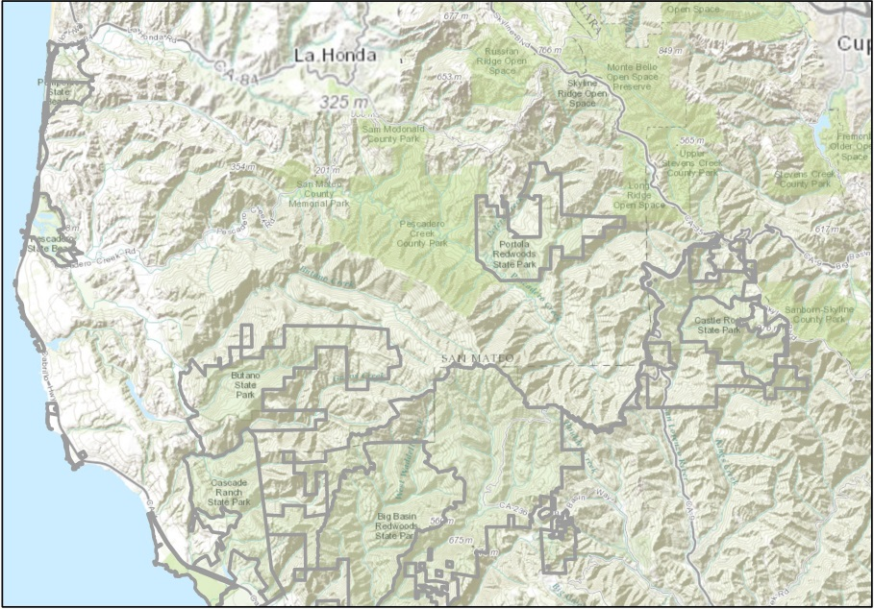
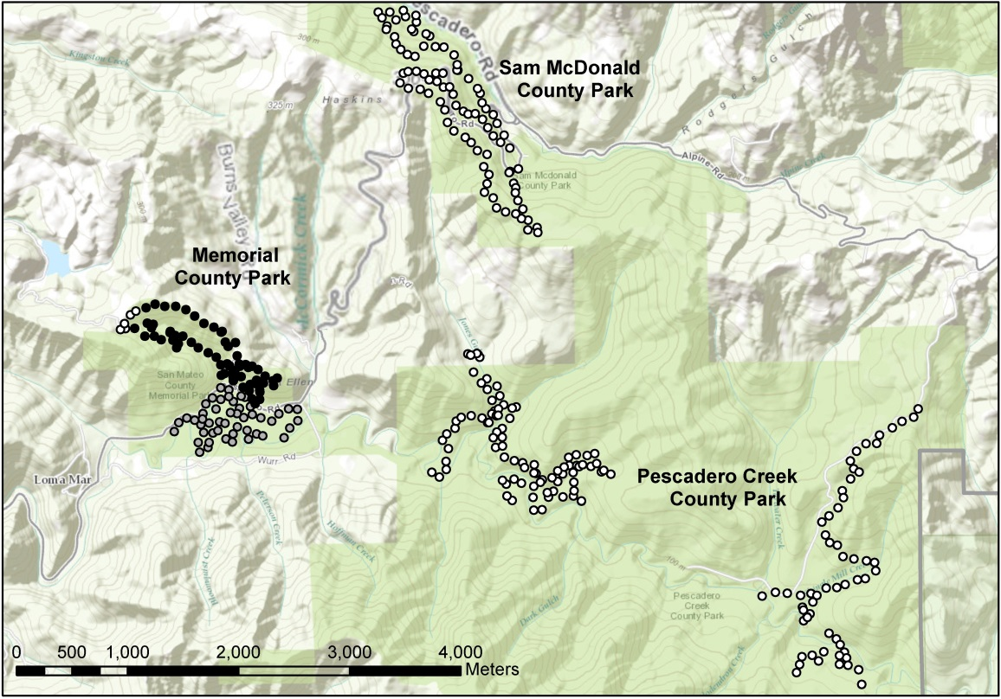
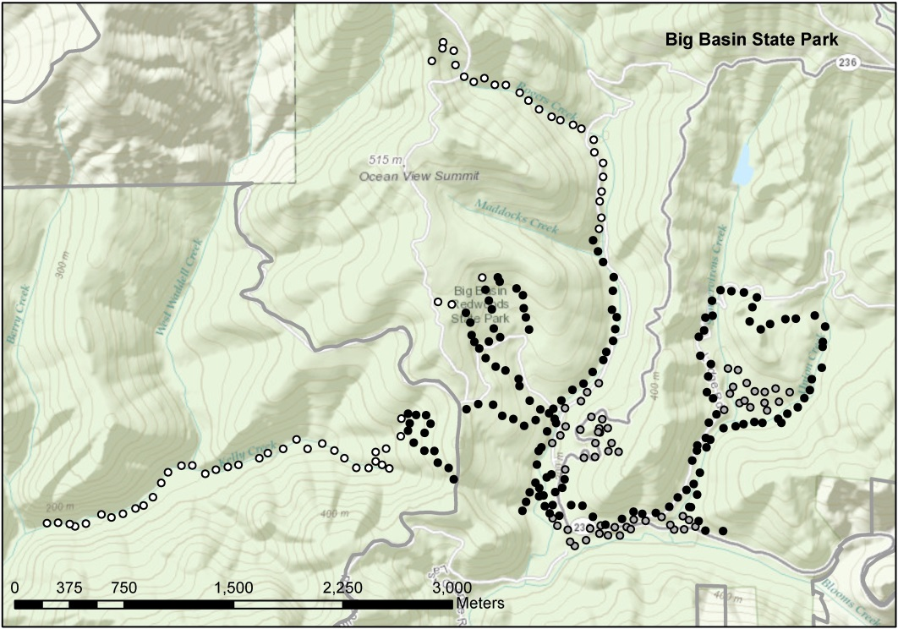

Figure 1. Locations of murrelet-mimic eggs in campgrounds (gray circles), within 1km of campgrounds (black circles), and more than 1 km away from campgrounds (white circles) in Big Basin State Park, Memorial County Park, Pescadero Creek County Park, and Sam McDonald County Park, California.
Figure 1. Locations of murrelet-mimic eggs in campgrounds (gray circles), within 1km of campgrounds (black circles), and more than 1 km away from campgrounds (white circles) in Big Basin State Park, Memorial County Park, Pescadero Creek County Park, and Sam McDonald County Park, California.
Figure 1. Locations of murrelet-mimic eggs in campgrounds (gray circles), within 1km of campgrounds (black circles), and more than 1 km away from campgrounds (white circles) in Big Basin State Park, Memorial County Park, Pescadero Creek County Park, and Sam McDonald County Park, California.
Figure 1. Locations of murrelet-mimic eggs in campgrounds (gray circles), within 1km of campgrounds (black circles), and more than 1 km away from campgrounds (white circles) in Big Basin State Park, Memorial County Park, Pescadero Creek County Park, and Sam McDonald County Park, California.
Table 1. Disposition of eggs after first and second treatments with murrelet-mimic eggs in 4 Santa Cruz mountain parks. Number of eggs shown for areas treated previously (in 2013 or 2014), and for areas treated for the first time in 2015.

Predation outcome | Sites treated previously in 2013/2014 |  |  | Sites treated only in 2015
Predation outcome | 1st treatment | 2nd treatment |  | 1st treatment | 2nd treatment
Big Basin State Park
Predated by corvid |  |  |  | 5 | 5
Possibly predated by corvid |  |  |  | 70 | 155
Not predated |  |  |  | 199 | 111
Total eggs with valid predation score |  |  |  | 274 | 271
Total eggs with unknown score  Total eggs revisited |  |  |  | 2 | 5
Total eggs revisited |  |  |  | 276 | 276
Memorial County Park
Predated by corvid | 13 | 4
Possibly predated by corvid | 33 | 19
Not predated | 74 | 97
Total eggs with valid predation score | 120 | 120
Total eggs with unknown score  Total eggs revisited | 1 | 1
Total eggs revisited | 121 | 121
Pescadero Creek County Park
Predated by corvid | 3 | 1 |  | 4 | 2
Possibly predated by corvid | 1 | 4 |  | 15 | 13
Not predated | 26 | 25 |  | 98 | 101
Total eggs with valid predation score | 30 | 30 |  | 117 | 116
Total eggs with unknown score  Total eggs revisited | 0 | 0 |  | 0 | 1
Total eggs revisited | 30 | 30 |  | 117 | 117
Sam McDonald County Park
Predated by corvid | 4 | 0 |  | 6 | 2
Possibly predated by corvid | 2 | 10 |  | 3 | 7
Not predated | 37 | 33 |  | 35 | 34
Total eggs with valid predation score | 43 | 43 |  | 44 | 43
Total eggs with unknown score  Total eggs revisited | 0 | 0 |  | 0 | 1
Total eggs revisited | 43 | 43 |  | 44 | 44

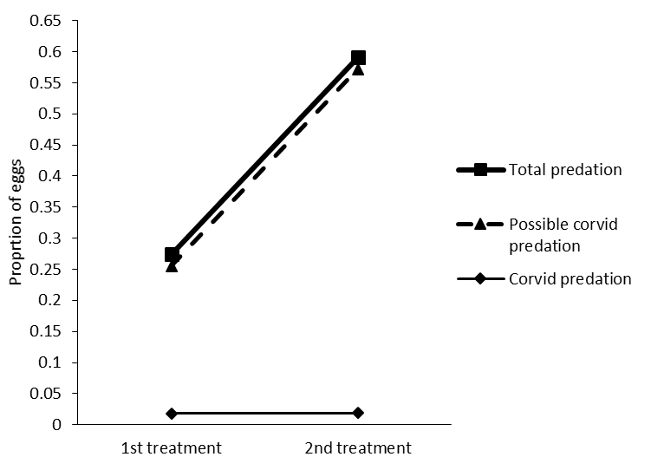

Figure 2. Proportion of eggs in three disposition categories, excluding unknown disposition, after first (n = 274), and second treatments (n = 271) of murrelet-mimic eggs in Big Basin State park.
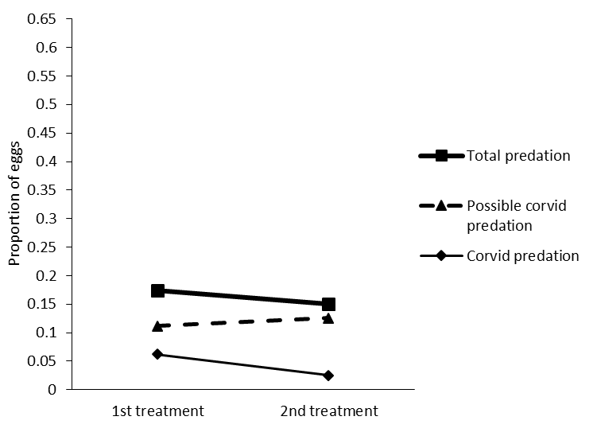

Figure 3. Proportion of eggs in three disposition categories, excluding unknown disposition, after first (n = 161), and second treatments (n = 159) with murrelet-mimic eggs in previously untreated areas of Pescadero Creek and Sam McDonald County parks.
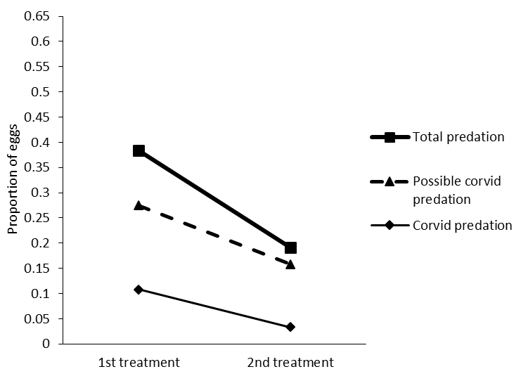

Figure 4. Proportion of eggs in three disposition categories, excluding unknown disposition, after first (n = 120), and second treatments (n = 120) of murrelet-mimic eggs in Memorial County park.
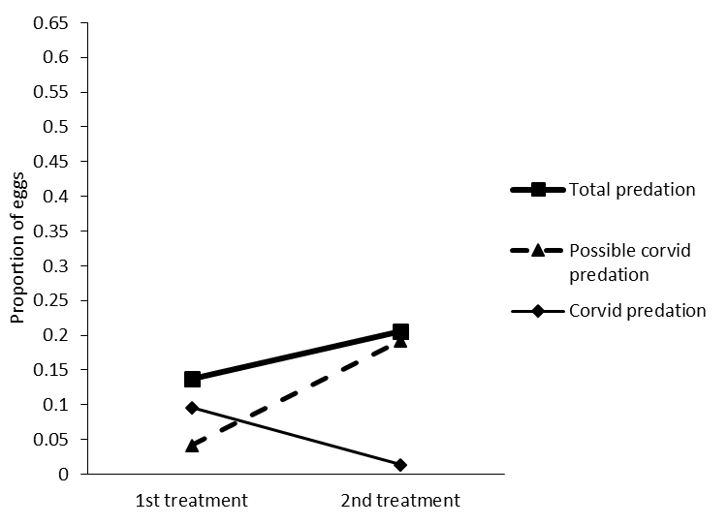

Figure 5. Proportion of eggs in three disposition categories, excluding unknown disposition, after first (n = 73), and second treatments (n = 73) of murrelet-mimic eggs in previously treated areas in Pescadero Creek and Sam McDonald County parks.
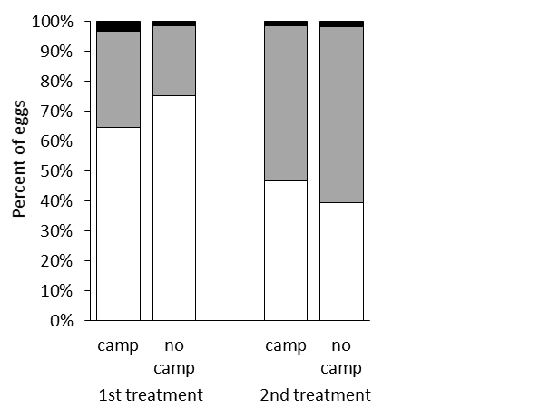
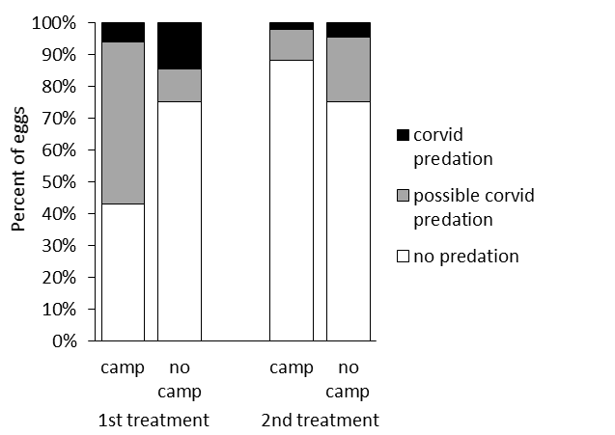
(b)
62 212 62 209 51 69 51 69

Figure 6. Proportion of eggs in three disposition categories, excluding unknown disposition, after first and second treatments with murrelet-mimic eggs in campgrounds (Camp) and outside of campgrounds (No camp) in a) Big Basin State Park, and b) Memorial County Park. Sample sizes shown inside bars.
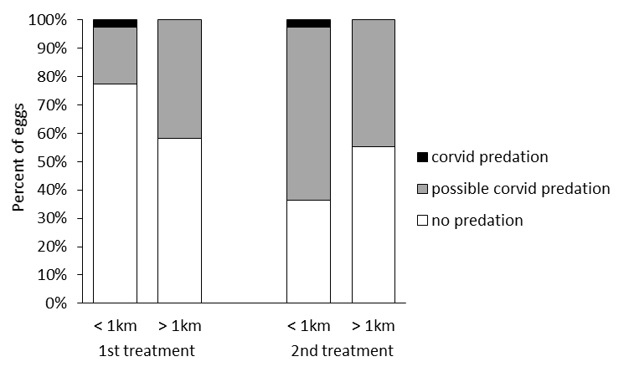
207 67 206 65

Figure 7. Proportion of eggs in three disposition categories, excluding unknown disposition, after first and second treatments with murrelet-mimic eggs within 1 km of campgrounds (< 1 km) and more than 1 km away from campgrounds (> 1 km) in Big Basin State Park. Sample sizes shown inside bars.

